**Setup-Instructions for ircDDBGateway with Icom hardware for DD-Mode**

This document describes how to setup a DStar-repeater with the G4KLX ircDDBGateway software and Icom hardware. It includes the setup of DStar DD-Mode with DHCP and shows how to connect it to the amprnet.

ircDDBGateway is a powerful, free and open gateway software written by Jonathan Naylor, G4KLX.  
It can be found in the Yahoo Group “ircddbgateway” (<http://groups.yahoo.com/group/ircDDBGateway>)

ircDDBGateway supports homebrew hardware as well as Icom hardware and also a mixed configuration of Icom and homebrew components.  
  
There is no homebrew hardware solution for DD-mode yet, the Icom RP2D is needed for DD-mode.

DD-mode with ircDDBGateway only works on LinuX systems, not on Windows!

Samples shown in this document are based on the setup of DB0MYK.  
All sample files will be supplied in a separate ZIP-file.

DD-Mode configuration is also part of the ircDDBGateway installation packages for CentOS5 and Debian (ARM and i386). Please note that the configuration files in the packages may look different and provide more options than the samples in this document. Also the setup of the package installation is usually done by a text based script, not by the GUI like shown in the samples of this document.

You are invited to add your comments, ideas, improvements, critics …

Hans-J. Barthen, DL5DI  
Franz-Josef-Str. 20  
56642 Kruft  
Germany  
Email: dl5di@darc.de

**Table of contents**

1. **Introduction**
2. **Setup of the Icom Gateway Controller RP2C**
3. **Setup of the Icom DD-Module RP2D**
4. **Setup of ircDDBGateway**
5. **Setup of the Gateway-PC**
6. **Optional Tools**
7. **Closing**

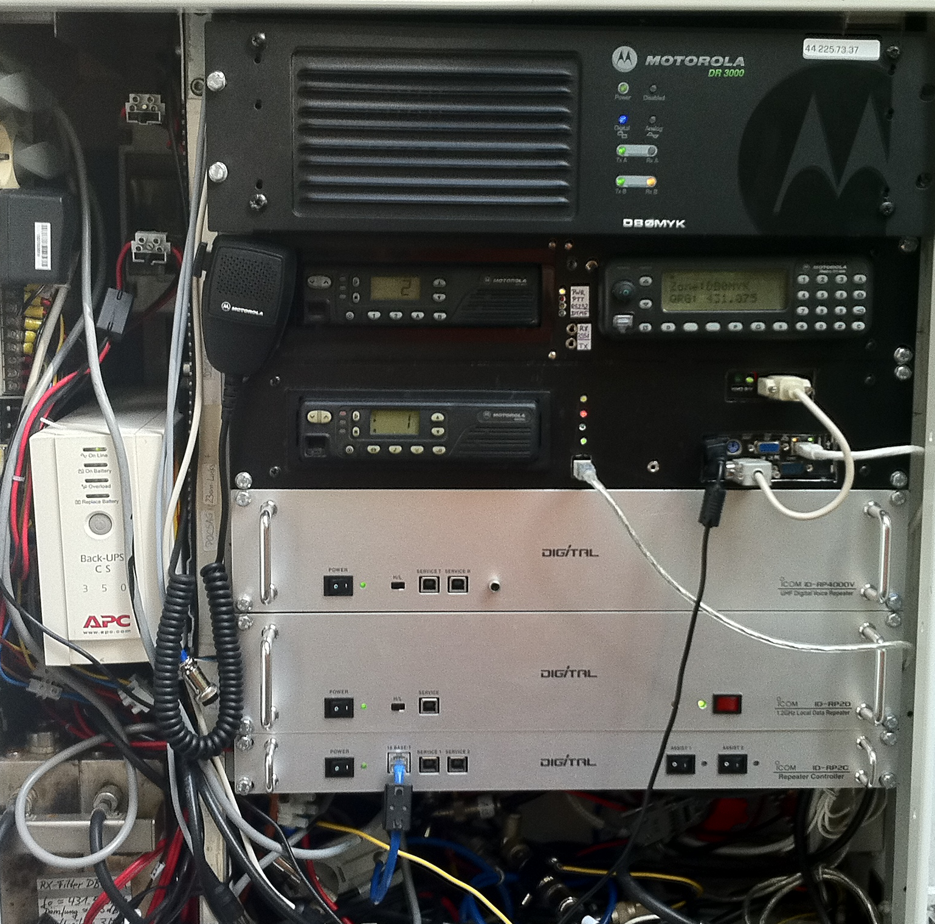

RP4000V, RP2D and RP2C at DB0MYK,   
next to APRS Digipeater, Echolink and DMR-Repeater.

1. **Introduction:**

**Hamnet/AmprNet**

At DB0MYK DStar-DD-mode allows users to access the “Hamnet”, which is the high speed part of the amprnet in Europe.

**The worldwide amprnet is our own closed network used for amateur radio only!  
For me it really makes sense to use it for DStar Digital Data.**

You will find more information on amprnet and hamnet in different languages on the web:

<http://en.wikipedia.org/wiki/AMPRNet> (English language)  
<http://db0fhn-i.ampr.org/doku.php?id=projects:wlan:hamnet> (English language)  
<http://www.amateurfunk-wiki.de/index.php/Kategorie:HAMNET> (German language)  
<http://de.wikipedia.org/wiki/HamNet> (German language)

and many more.

**DHCP**

My setup at DB0MYK provides all necessary network information by DHCP.

The big advantage of DHCP is that users without any network knowledge may use it easily.  
It is as easy as connecting a PC to a usual DSL- or WLAN-router.  
Not all OMs are network and internet specialists.

A disadvantage of DHCP is a changing IP address which makes peer-to-peer routing more complicated.  
I personally do not think that P2P routing is the main purpose of DStar-DD. Most users do not run any services on their PC that might be connected from the net; a standard Windows installation with firewall enabled will not even answer a ping by default.  
Servers should be connected to the network by a faster link, however, they could also get fix IPs.

But anyway, I have built a little web-tool which shows the actual users from the DDMode.log of ircDDBGateway with the current IP address from DHCP-leases. Users can see on a webpage of the gateway who is on air in DD and what the actual IP address is.

There is much room for improvement at that place; dynamic IP addresses should not be an unsolvable issue!

**2. Setup of the Icom Gateway Controller RP2C**

The setup of the RP2C is as usual:

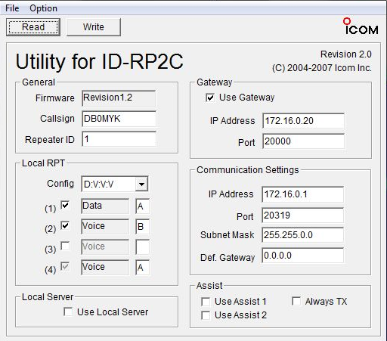

This setup shows a data module A and a voice module B enabled.

Adjust the settings to your need.  
Consult your Icom manual for more details.  
There is no special requirement for ircDDBGateway.

**3. Setup of the DD-Module RP2D**

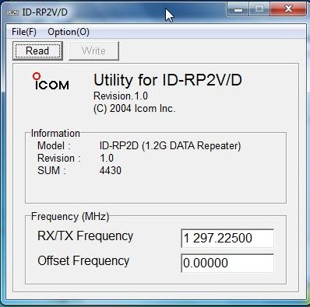

This is as easy as it looks like:  
Connect your PC to the repeater module by USB, start the Icom configuration utility, which is the same for RP2V and RP2D, and set frequency and offset.  
DD-mode is a simplex mode and usually runs without offset.   
More details may be found in the Icom manual.

**4. Setup of ircDDBGateway**

Connect your controller to the gateway PC.

After installation start “ircddbgateway” and open the preferences.

Enter the first menu for “Gateway” settings:

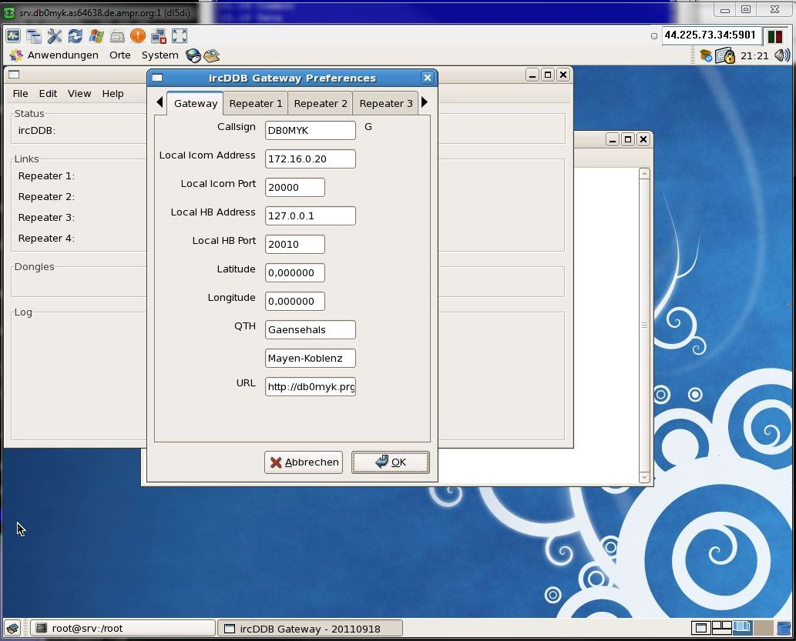

Fill in local Icom address and port like shown above.  
Fill in latitude and longitude values of your gateway’s location.  
Fill in QTH and URL to your homepage.

Note that decimal delimiters depend on your locale settings.

Press ‘OK’ when finished.

Change to the second menu to configure “Repeater 1”:

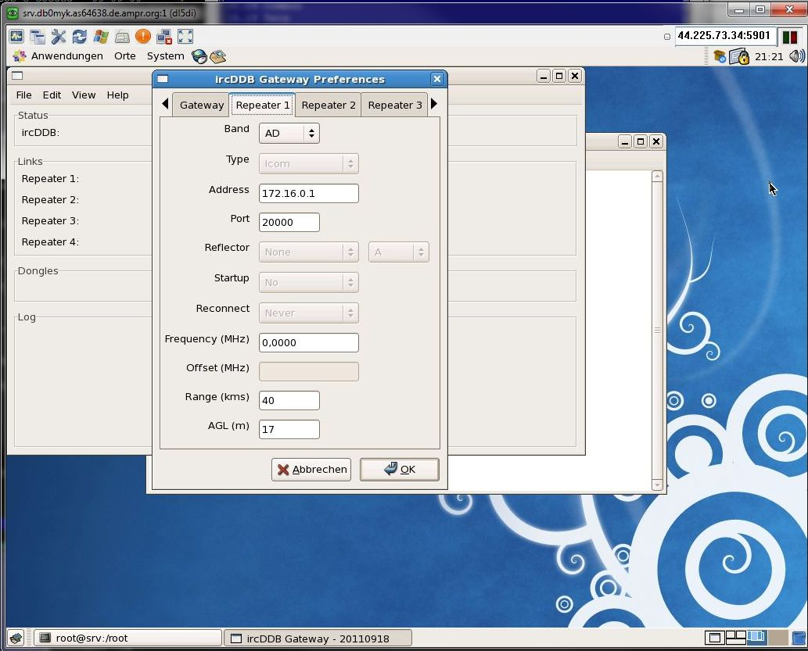

In my sample I selected band “AD” which is the usual DD-modul on Band “A”.

Enter the required data.

**Note:** The values for “Address” and “Port” are the same for all modules connected to the Icom controller!

Enter “Frequency” **in MHz**, “Range” **in kilometer**.  
AGL is the Antenna height **above GroundLevel !**

Press ‘OK’ when finished.

Step to menu “Repeater 2”:

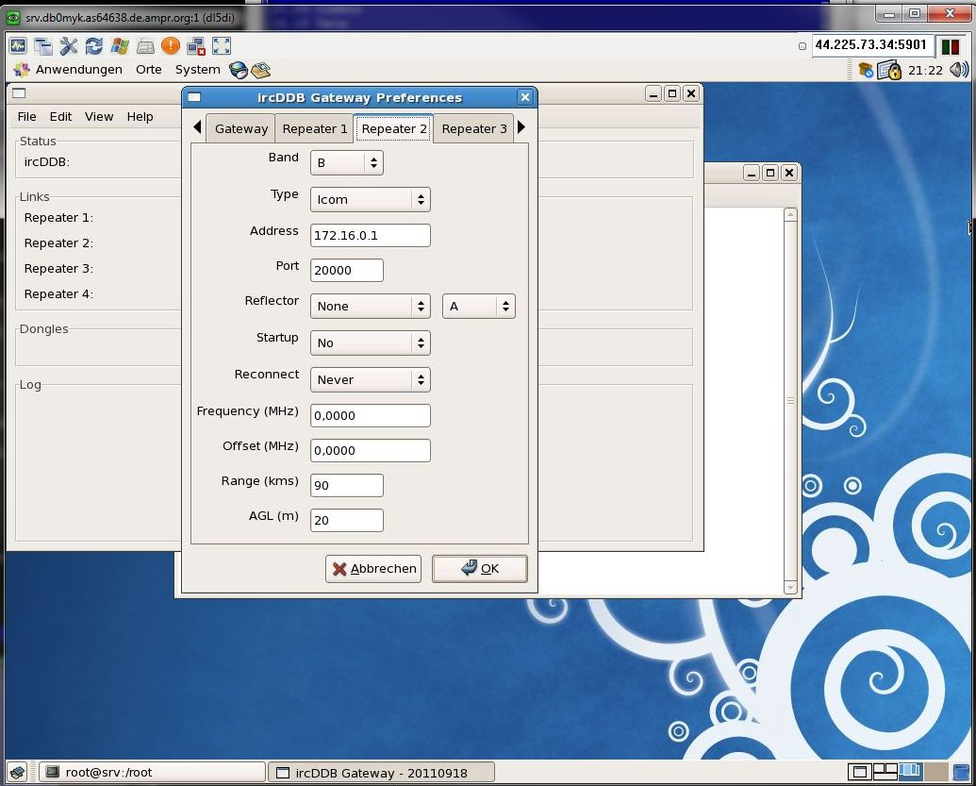

In my sample I used it for the 70cm DV module on Band “B”.

**Note:** The values for “Address” and “Port” are the same for all modules connected to the Icom controller!

Enter “Frequency” **in MHz**, “Range” **in kilometer**.  
AGL is the Antenna height **above GroundLevel !**

Press ‘OK’ when finished.

Fill more sheets for more modules as needed.

Step to Menu “ircDDB”:

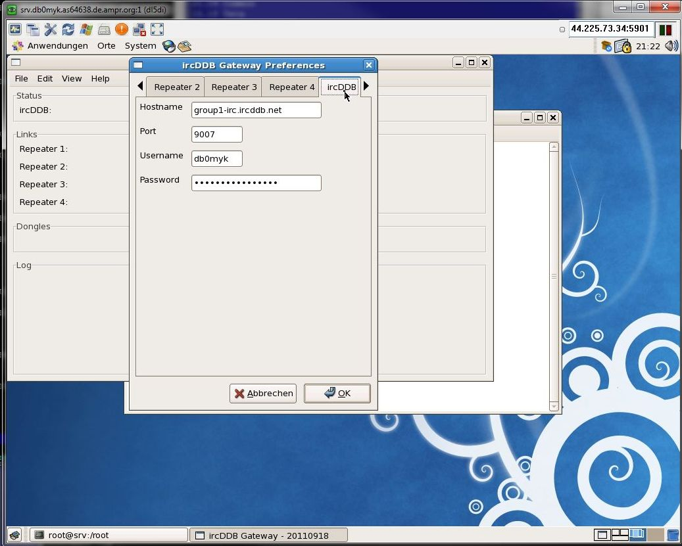

Data entered in this menu are necessary to log into the ircDDB routing network.

The first field is the ‘Hostname’ of an ircDDB server group.  
ircDDB uses 2 different groups of servers.

If you are located in North America please enter ‘group2-irc.ircddb.net’,  
use ‘group1-irc.ircddb.net’ outside of North America.

The port should always be 9007.

“Username” is usually the callsign of the gateway, the “Password” is a 16 digit random string that you got by email after registration on the ircDDB registration website <http://regsrv.ircddb.net>.

Press ‘OK’ when finished.

Select menu “D-PRS”:

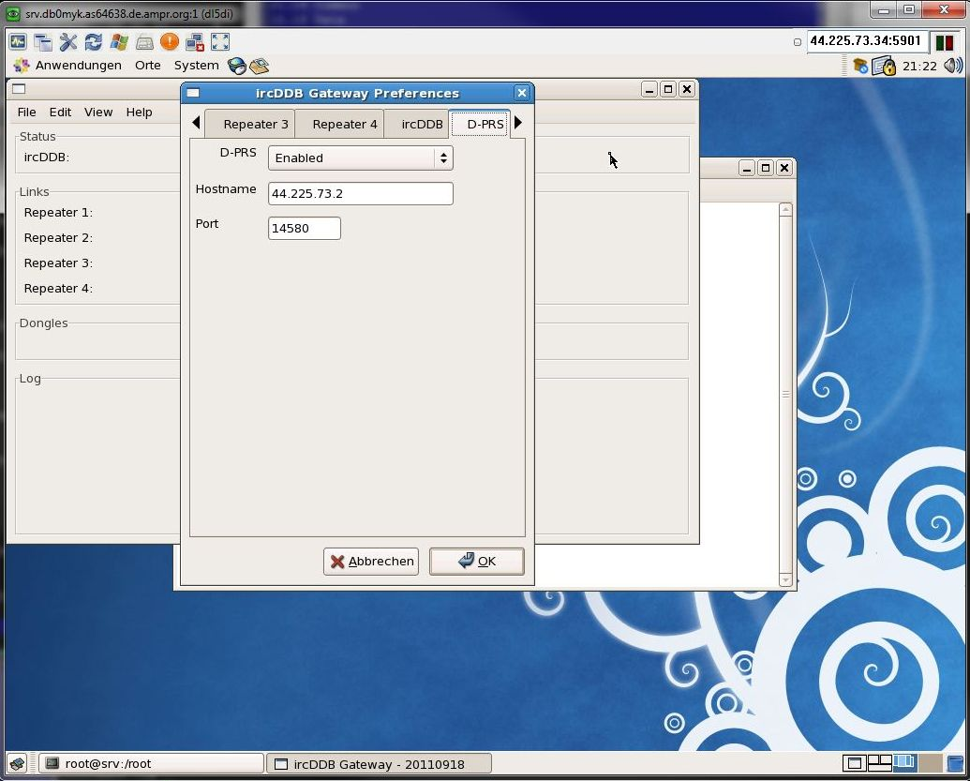

Enter the network address and port of your favorite APRS server.  
Please find more information here: <http://www.aprs2.net>

At DB0MYK I use a server which offers a port on the amprnet.

Next 2 menus are for configuration of reflector settings.  
  
ircDDBGateway supports both reflector networks, DPlus and XReflector.

**DEXtra-Setup**

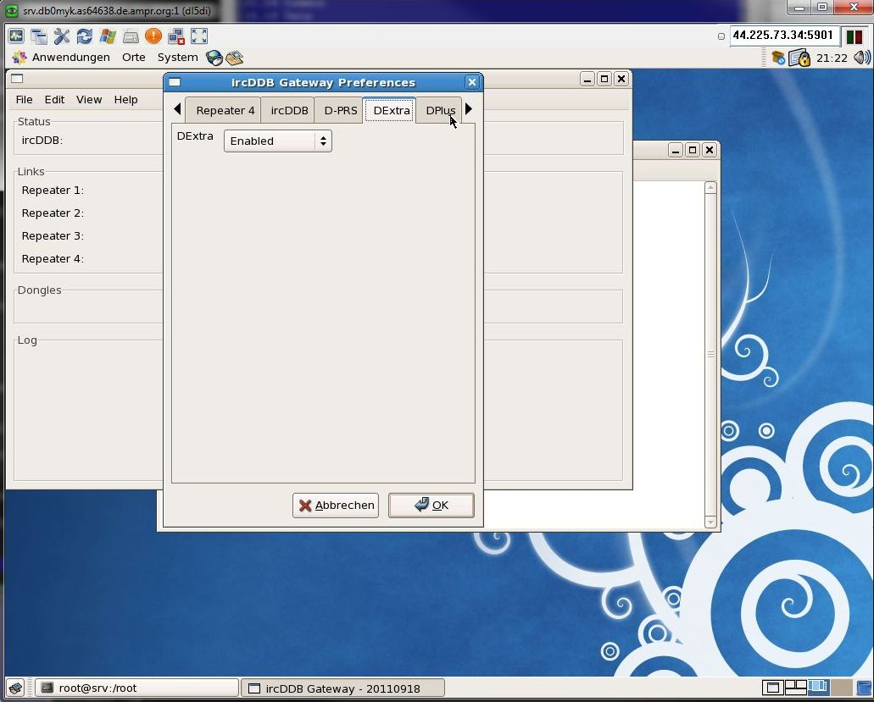  
Check if you want to enable/disable DExtra reflector feature.

**DPlus-Setup**

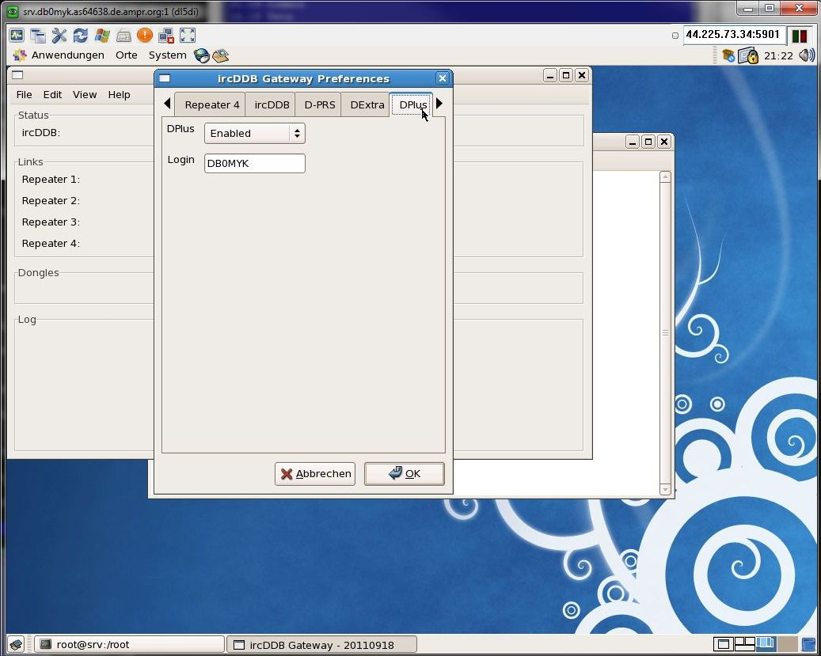

Check if you want to enable DPlus reflector feature.

Enter a callsign which is used to login to the DPlus network.  
This callsign has to be a registered user callsign at the US trust network.

**Note:**

User registering of a gateway callsign at the US trust network may cause routing issues.  
Please use a real user callsign at this place, no gateway callsign!

Next menus are for setting up StarNet servers:

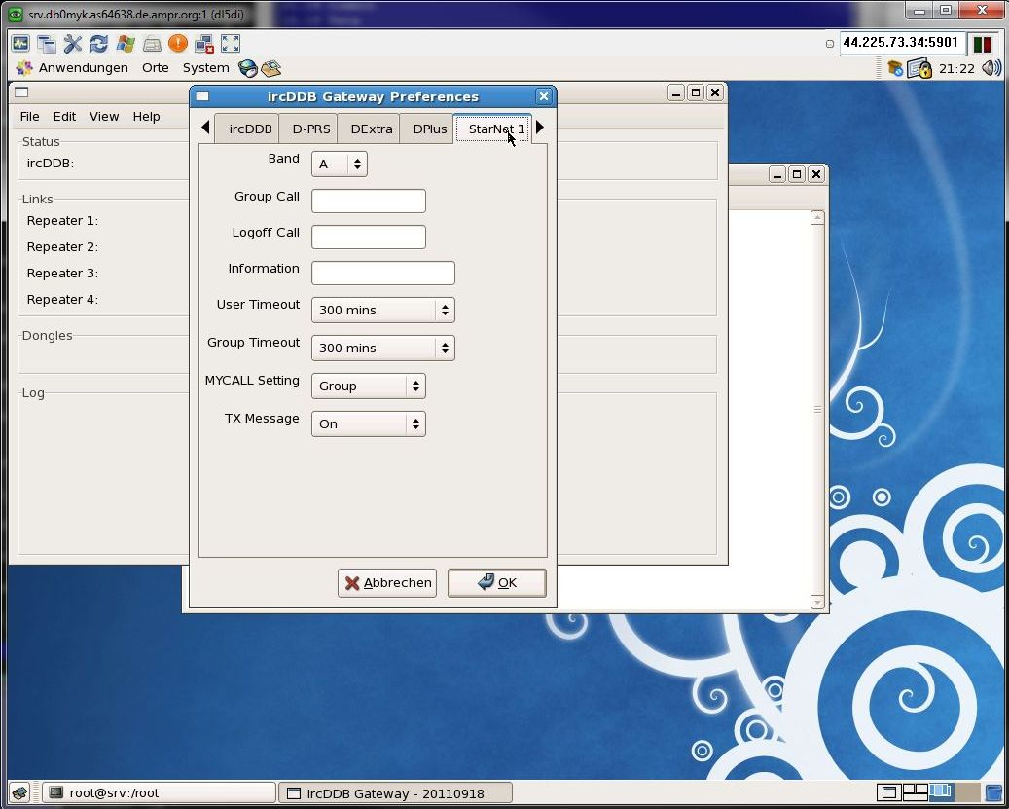

The folder “Remote” allows to configure access for a remote control console.  
The console is part of the software package, it is a nice tool to link and unlink reflectors.

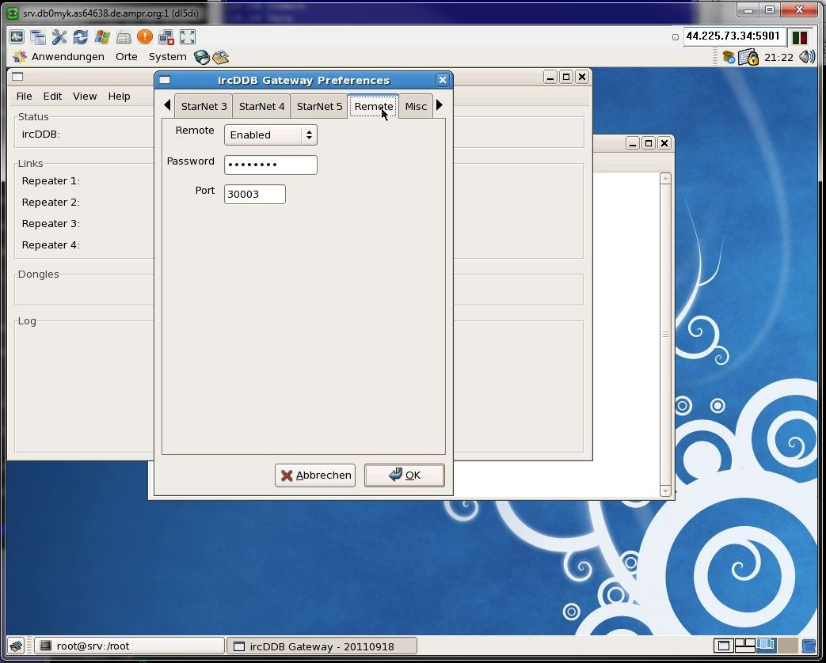

The last configuration folder is for setup of some “Misc” features:

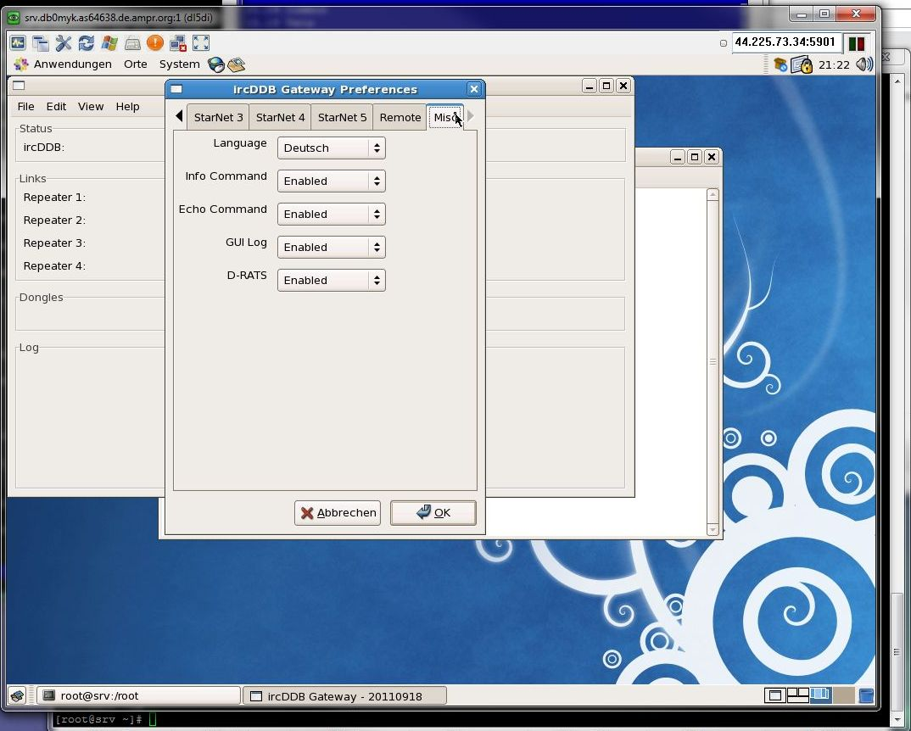

Select the language for your gateway and the commands “Info” and “Echo” known from DPlus.

You can also enable logging, which is necessary to get John’s dashboard work which can be found in the files section of the ircDDBGateway Yahoo-Group.

1. **Setup of the Gateway-PC for DD-Mode**

**5.1 Network device settings**

If a DD-port is enabled ircDDBGateway will create a network device ‘tap0’ on the gateway PC.

Configure this new device to your needs:

**/sbin/ifconfig tap0 *44.225.73.65* netmask *255.255.255.240***

Activate IP forwarding:

**echo 1 > /proc/sys/net/ipv4/ip_forward**

***OR***

**/sbin/**sysctl -w net.ipv4.ip_forward=1

Open a terminal window and enter “/sbin/ifconfig” to check the network device settings.  
You should get something like this:

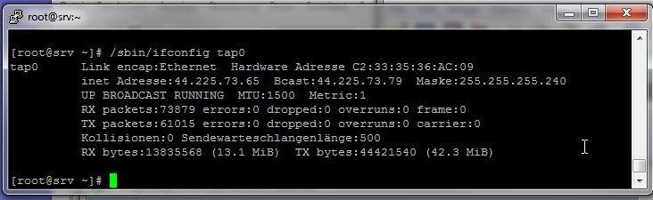

A route is created automatically.  
Check it with “/sbin/route –n”

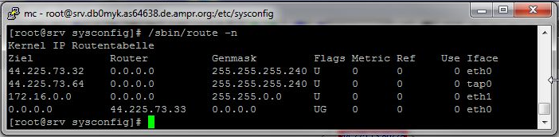

In my sample it shows the network 44.225.73.64/255.255.255.240 routed through tap0.

**PLEASE NOTE:**

**The following sample is based on my own configuration.**

**The shown IP addresses may not be used in your setup !**

**The 44.x.x.x is no free available address block, this is the amprnet, the IPs need to be registered!**  
Contact your local address coordinator if you want to connect to the amprnet, which to my mind makes really sense.

**5.2 DHCP setup**

The easiest way for users is to work with DHCP on the DStar-DD user port.  
  
It is much easier than working with registrations and fix IP addresses per device.  
DHCP will supply all necessary network settings; the user usually does not have to configure anything on the PC.   
DHCP is used by default on Windows systems to configure network devices.

After connecting PC and ID1, configuring the amateur radio specific settings like frequency, offset and mode, entering the D-Star specific addresses (mycall, urcall, rptr1, rptr2), all network settings will be set up automatically.

A short documentation for users will be supplied in a separate document.

In my sample the dhcp server only answers DHCP requests on the tap0 device created by ircDDBGateway.  
The IP address range is from the subnet ‘44.225.73.64/28’.  
A subnet of ‘/28’ (which is equivalent to netmask 255.255.255.240) offers 16 addresses, from which 13 may be offered to users by the dhcp server. This is usually more than enough with an appropriate lease time.

Based on my sample the subnet used on the DD-port looks like this:

44.225.73.64 network address  
44.225.73.65 address used by the D-Star-gateway/DHCP-server/router  
44.225.73.66 - 44.225.73.78 range for DHCP  
44.225.73.79 broadcast address

Here my configuration file ‘/etc/dhcpd.conf’ for the DStar-DD-port of DB0MYK :

#  
# dhcpd.conf  
## Hosts with more than one interface MUST specify a ``server-identifier'',  
# which should be the IP address of the server's primary network interface,  
# or if there is no interface that can be described that way, at least an  
# interface whose address isn't likely to change.  
server-identifier *44.225.73.65*;  
authoritative;  
# option definitions common to all supported networks...  
use-host-decl-names on;  
ddns-update-style none;  
default-lease-time 3600; # 1 hour  
max-lease-time 86400; # 1 day  
option subnet-mask *255.255.255.240*;  
option domain-name "*db0myk.de.ampr.org*";  
option domain-name-servers *44.225.73.2*;  
option rfc3442-classless-static-routes code 121 = array of unsigned integer 8;  
option ms-classless-static-routes code 249 = array of unsigned integer 8;  
#  
subnet *44.225.73.64* netmask *255.255.255.240* {  
 option subnet-mask *255.255.255.240*;  
 option domain-name "*db0myk.de.ampr.org*";  
 option domain-name-servers *44.225.73.2*;  
 option ntp-servers *44.130.42.100*;  
 option rfc3442-classless-static-routes *8, 44, 44,225,73,65*;  
 option ms-classless-static-routes *8, 44, 44,225,73,65*;  
#;  
 range *44.225.73.66 44.225.73.78*;  
}

**DO NOT USE THESE ADRESSES!**

**THIS IS MY ADRESS SPACE AND IT IS IN USE!!**

Start the DHCP server with ‘/sbin/service dhcpd start’.

Please check the appropriate documents for dhcp options.

**5.3 Test**

Now it is time to take your ID1 and check if your gateway really works!

**Setup the ID1:**

* Tune the ID1 to the frequency of your DD-mode repeater module.
* Select DD-Mode.
* Activate the correct repeater mode.  
  The ID1 offers ‘RP+’,’ RP-‘ and ‘RPS’.  
  ‘+’/’-‘ for the direction of offset and ‘S’ for simplex.   
  Most DD-mode repeaters work simplex, note that you have to set ‘RPS’ in that case!  
  Without any repeater setting DD-mode won’t work.
* After that you need to enter your own callsign, destination, repeater 1 and repeater 2.  
  This works exactly in the same way like for digital voice:
* Set destination to “CQCQCQ”,
* Set repeater 1 to the callsign and ID that your local repeater uses for the DD-module.   
  Usually it is the ID “A” at the 8th position, like “DB0MYK_A”.
* Set repeater 2 to the gateways’ callsign.  
  Usually it is the repeaters’ callsign with the ID “G” at the 8th position, like DB0MYK_G.

If you have installed the remote control software on a PC, settings should look like this:

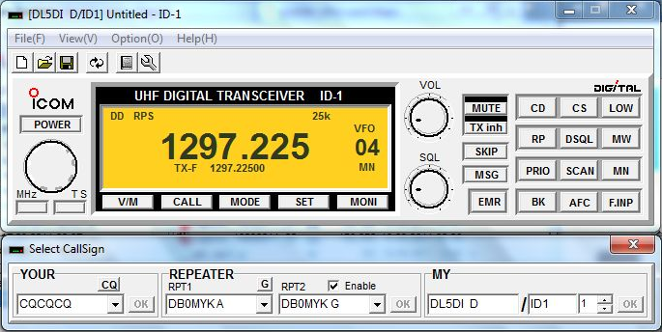

**Set up your PC**

* If you are using a Windows PC and have not done any changes to the settings of the Ethernet interface yet, you have nothing to configure at all.
* If you did manual changes to the network settings, take care that the Ethernet interface has to be activated and set to DHCP mode.

**Connect the devices**

* Connect your PC and the ID1 by using a standard network cable.
* The transmitter of the ID1 is deactivated by default, it shows ‘TXinh’ in the display.  
  Activate your ID1 by pressing the ‘TXinh’ button.

‘TXinh’ should now have disappeared from the display and you should immediately see some traffic going back and forth.   
Your PC will send out a DHCP request immediately after the interface gets connected and tries to get an IP address.  
The gateway will supply the IP and some other necessary network settings.

Open a command window on your PC and check the Ethernet device settings.

On a Windows PC enter ‘ipconfig’, the output should look like this:

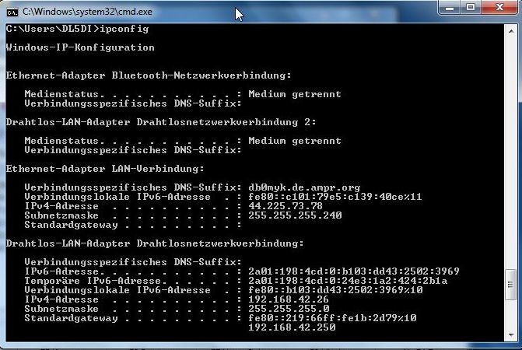

Good!

The system has got an IP address out of the configured range 44.225.73.66 to 44.225.73.78 and the network mask is set correct. There is no default gateway set on this device.

‘route print’ shows if a static route is set up:

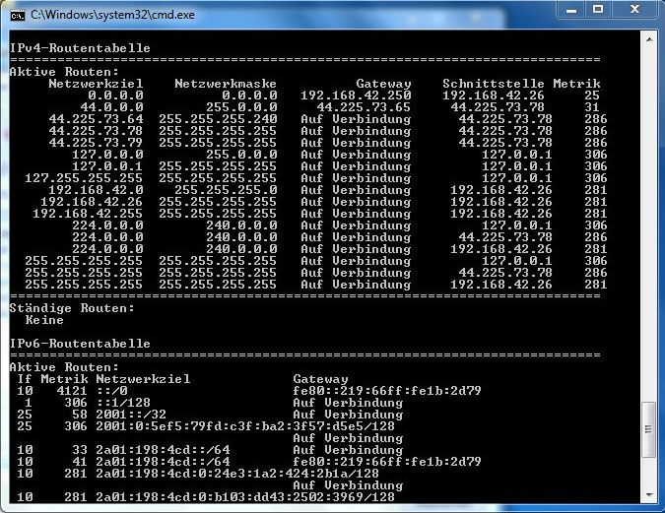

Note that this setup only routes amateur radio addresses (44.0.0.0/255.0.0.0) via DD-mode.  
There is no default route to the gateway which would be used for any internet traffic.  
This setup can be used parallel to a second network interface which is connected to the internet.

The responsible options for the correct routing in the dhcp.conf file from above are:

option rfc3442-classless-static-routes code 121 = array of unsigned integer 8;  
option ms-classless-static-routes code 249 = array of unsigned integer 8;

option rfc3442-classless-static-routes *8, 44, 44,225,73,65*;  
option ms-classless-static-routes *8, 44, 44,225,73,65*;

There is one set of options which uses the RFC3442 standard for classless static routes, a second set is specific for Windows based clients. The options are followed by a comma separated list of integer values. Please find more information in the man-pages available on the web. The values in this case are:

*8 subnet mask (specified in bits)  
44 network address  
44 225 73 65 router address*

**5.4 Configure automatic startup**

If everything worked fine so far you will need to get it all to start automatic after  
  
a reboot.  
I used the startup script from John Hays/K7VE, which can be found in the files area of the Yahoo Group “ircDDBGateway”, and modified it for DD-mode.

The modifications are marked.  
This modified startup script restarts the DHCP server each time when tap0 has been created new by a restart of ircDDBGateway.

Note that there are several ways to enable routing on your LinuX machine, select your preferred solution:  
Most common is to use ‘**echo 1 > /proc/sys/net/ipv4/ip_forward’** .  
You may also use ‘**/sbin/**sysctl -w net.ipv4.ip_forward=1’.  
Another way is to edit the file /etc/sysctl.conf and set ‘net.ipv4.ip_forward=1’ in it. The default setting is 0.

Sample of /etc/init.d/ircddbgateway for CentOS5 systems :

#!/bin/bash  
#  
# ircDDBGateway startup script  
# John Hays (K7VE) - [john@hays.org](mailto:john@hays.org)  
#  
# chkconfig: 2345 99 01  
# description: Starts the G4KLX ircDDBGateway  
# config: /etc/sysconfig/ircddbgateway  
#  
if [ $UID != 0 ]; then  
 echo  
 echo "ERROR: This script must be run as the root user!"  
 echo " Please use 'su' or log in as root and try again."  
 echo  
 exit 1  
fi  
me=ircddbgateway

# Source function library.  
. /etc/rc.d/init.d/functions

Please note that the installation packages for CentOS and Debian provide scripts which are different. Features for DD-mode are included, no adjustments necessary!

# Source networking configuration.  
[ -r /etc/sysconfig/network ] && . /etc/sysconfig/network

# Check that networking is up.  
[ "${NETWORKING}" = "no" ] && exit 1

# Source the configuration  
[ -f /etc/sysconfig/$me ] && . /etc/sysconfig/$me

start() {

echo -n "Starting $me:"  
 daemon --pidfile /var/run/$me.pid $DAEMON_PATH $DAEMON_OPTIONS   
 RETVAL=$?  
 [ $RETVAL -eq 0 ] && touch /var/lock/subsys/$me  
 pidofproc $DAEMON_PATH > /var/run/$me.pid  
 echo  
 sleep 2  
 # create a watchdog entry to the crontab  
 echo "*/10 * * * * root ps aux | grep $DAEMON_PATH | grep -vq grep || /etc/init.d/$me start" > /etc/cron.d/$me  
 if [ "${IRCDDBGATEWAY_DDENABLED}" = "yes" ];then  
 echo " - configure dd-mode network device $IRCDDBGATEWAY_DDDEV "  
 sleep 15  
 /sbin/ifconfig $IRCDDBGATEWAY_DDDEV $IRCDDBGATEWAY_DDIP netmask $IRCDDBGATEWAY_DDMASK  
 echo 1 > /proc/sys/net/ipv4/ip_forward  
 if [ "${IRCDDBGATEWAY_DDDHCP}" = "yes" ];then  
 echo " - start dhcpd "  
 /sbin/service dhcpd start  
 fi  
 fi  
}

stop() {

echo -n "Stopping $me "  
 if [ "${IRCDDBGATEWAY_DDENABLED}" = "yes" -a "${IRCDDBGATEWAY_DDDHCP}" = "yes" ]; then  
 echo " - dhcp for dd-mode is enabled, stop it "  
 /sbin/service dhcpd stop  
 sleep 15  
 fi   
  
 killproc $DAEMON_PATH

RETVAL=$?  
 [ $RETVAL -eq 0 ] && rm -f /var/lock/subsys/$me  
 # remove watchdog entry from crontab  
 rm -f /etc/cron.d/$me   
 echo  
}

restart() {

stop  
 sleep 2  
 if [ "${IRCDDBGATEWAY_DDENABLED}" = "yes" -a "${IRCDDBGATEWAY_DDDHCP}" = "yes" ]; then  
 sleep 15  
 fi  
 start  
}

*... and so on / rest untouched...*

Delays are necessary to give the software time to create the device and configure it.

This DD-Mode configuration is part of the startup-files in the standard packages for CentOS5 and Debian.

The parameters for DD-mode on CentOS installations are set in

/etc/sysconfig/ircddbgateway

and for Debian installations and in

/etc/default/ircddbgateway

Sample settings:

..

IRCDDBGATEWAY_DDENABLED="yes"  
IRCDDBGATEWAY_DDDHCP="yes"  
IRCDDBGATEWAY_DDDEV="tap0"  
IRCDDBGATEWAY_DDIP="192.168.1.123"  
IRCDDBGATEWAY_DDMASK="255.255.255.0"  
..

**Please note** that this configuration only works when ircddbgateway is started from the startup script in daemon mode!

The packages provide a script ircddbgateway.sh which also activates the DD-mode when ircDDBGateway is started in GUI mode *(it also sets the en_US numeric locale to fix the decimal delimiter issue in some countries)*

**Startscript to enable DD-Mode in GUI mode:**

(/usr/local/bin/ircddbgateway.sh on CentOS5 and /usr/bin/ircddbgateway.sh on Debian)

#!/bin/bash  
#  
# ircDDBGateway start script for GUI  
# Hans-J. Barthen (DL5DI) - [dl5di@gmx.de](mailto:dl5di@gmx.de)  
#  
# description: Starts the G4KLX ircDDBGateway in GUI mode and sets the LC_NUMERIC LOCALE  
# to en_US.UTF-8 to make the configfile compatible for GUI and daemon mode.  
# config: /etc/sysconfig/ircddbgateway  
#

if [ $UID -ne 0 ]; then  
 echo  
 echo "ERROR: This script must be run as the root user!"  
 echo " Please use 'su' or log in as root and try again."   
 echo  
 exit 1  
fi

Please note that the installation packages for CentOS and Debian provide scripts which are different. Features for DD-mode are included, no adjustments necessary!

NAME=ircddbgateway  
  
LC_NUMERIC="en_US.UTF-8" /usr/local/bin/$NAME -gui &

# Take care to start necessary services for DD-mode if enabled

# Read configuration file if it is present  
[ -r /etc/**sysconfig**/$NAME ] && . /etc/**sysconfig**/$NAME || echo "Configfile /etc/**sysconfig**/$NAME is missing"

if [ "${IRCDDBGATEWAY_DDENABLED}" = "yes" ];then  
 echo " - configure dd-mode network device $IRCDDBGATEWAY_DDDEV "  
 sleep 15  
 /sbin/ifconfig $IRCDDBGATEWAY_DDDEV $IRCDDBGATEWAY_DDIP netmask $IRCDDBGATEWAY_DDMASK  
 echo 1 > /proc/sys/net/ipv4/ip_forward  
 if [ "${IRCDDBGATEWAY_DDDHCP}" = "yes" ];then  
 echo " - start dhcpd "  
 /etc/init.d/dhcpd start  
 fi  
fi

This is the version for CentOS.

Change the marked pathnames from “/etc/sysconfig” to “/etc/default” and “/usr/local/bin” to “/usr/bin” for Debian.

1. **Optional Tools**

I created a dashboard option which shows DHCP leases on the web.  
With this version the script shows Callsign, IP address and lease time, so it allows local users to find each other for direct connects when using DHCP addresses.  
The output can be found here: <http://dstar.prgm.org>

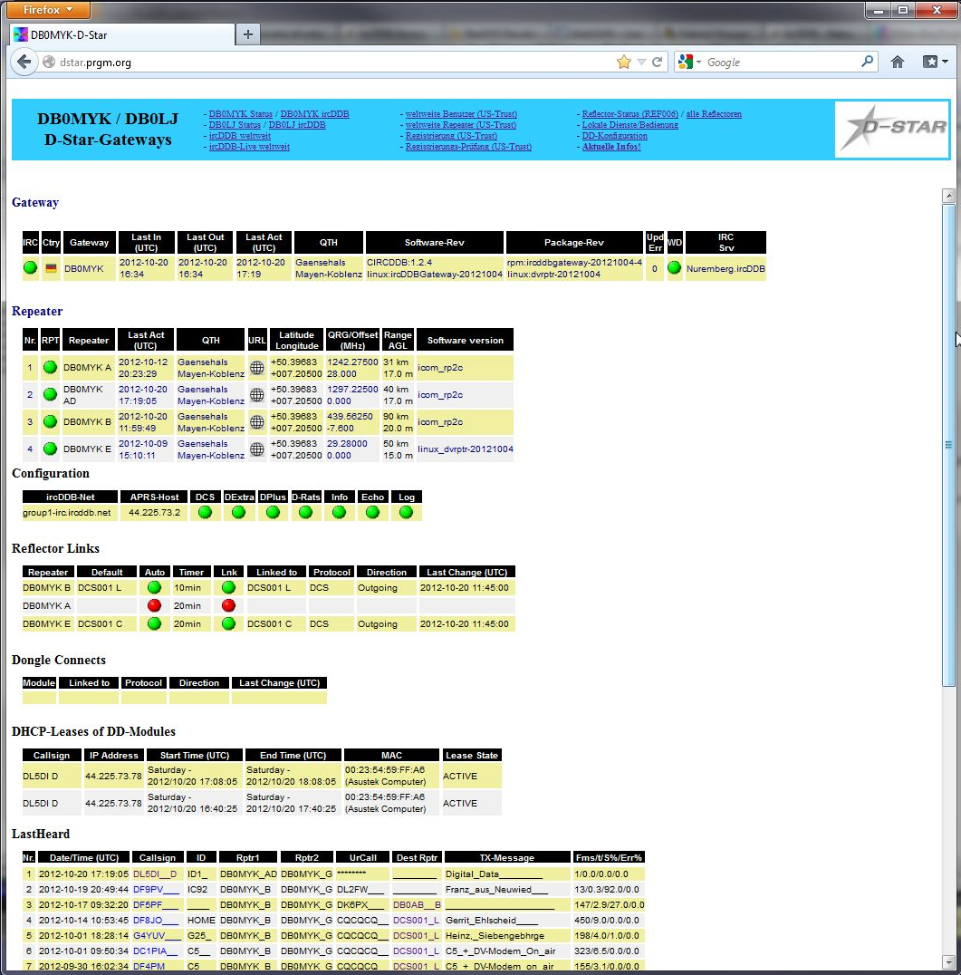

1. **Closing**

I hope this documentation helps to get some more DStar-DD-Repeaters to the worldwide network.

128kBit/s is not the speed like used on the WLAN-based part of the Hamnet, nothing for Video streams and fast file transfers, but it is much faster and comfortable than usual Packet-Radio speeds and has a much better coverage range than WLAN in areas which are not flat and less populated with hams like here.  
It is much more effective.

Yes, the ID1 is expensive and there is no alternative available, but it is a nice radio, analog and digital voice, digital data, high-speed modem and ‘tnc’ all integrated.

It really works Plug&Play if the repeaters do support it, like it can easily be done with ircDDBGateway!

Have fun with DStar Digital Data and join the ircDDB network!

Hans-J. Barthen, DL5DI

ircDDB Team  
<http://www.ircddb.net>